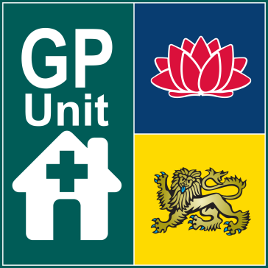

# 2014-04-03 11Video observation of consultation

*Located:*  
**Fairfield Hospital**cnr Polding St & Prairievale Rd  
Prairiewood NSW 2176

Direct observation helps our family medicine trainees to learn and to become better doctors.

In your next consultation, one of our ***senior supervising GPs*** will be watching ***your doctor*** using a video camera. Your visit with the doctor will otherwise be the same.

**Your doctor**



**Supervising**

**doctor**

## Your rights

You can:

* Ask for the camera to be turned off at ***any time***
* Ask to be shown where the camera is located
* Ask to speak to the supervising doctor
* Change your mind any time without explaining this to the doctor

## Our responsibilities

We will:

* Inform you about the video observation
* Ask for your permission before starting
* Show you the location of the camera
* Respect your privacy
* Not use the video observation for any other purpose without your permission
* Not share the video without your permission

**Thank you very much for contributing to the medical education and training of our students and junior doctors!**